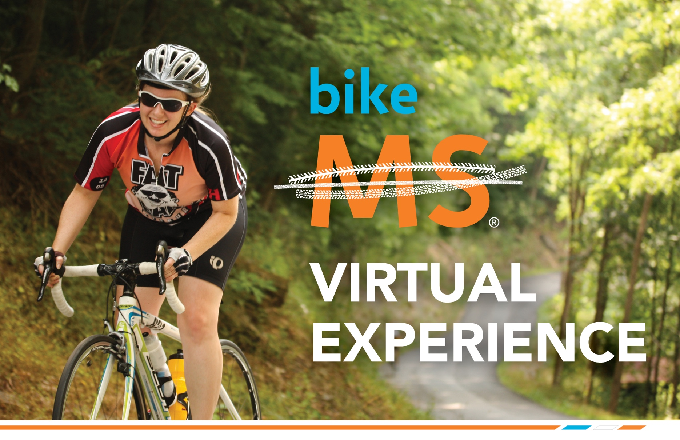

Welcome to the
Bike MS® Virtual Experience!
As we prepare for Virtual Bike MS: Ride Name we wanted to send you your Digital Bike MS Bib for use ride weekend!
We want to see your Bike MS personality! Customize your digital Bike MS bib prior to printing:
- Add your name and team name (if you are riding with a team)
- Add the appropriate sticker(s) to your bib by sliding the ‘sticker’ image(s) onto your digital Bike MS bib
- Add hashtags and team logos to show your spirit as well

Wear and share your bib ride weekend
Once you have customized your digital Bike MS bib, print it for use! Wear and share your bib with others through photos and social media while taking part in Virtual Bike MS. We want to see your bibs! Don’t forget to use the hashtags #VirtualBikeMS and #BikeMS!

Digital Bibs — General Template
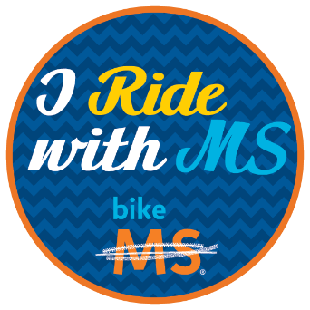
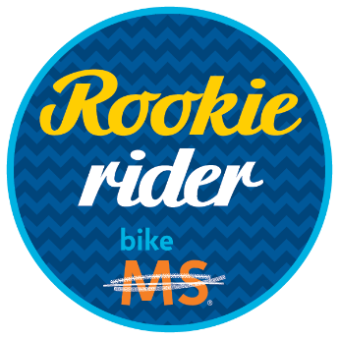
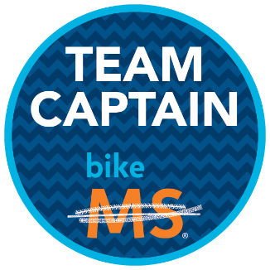
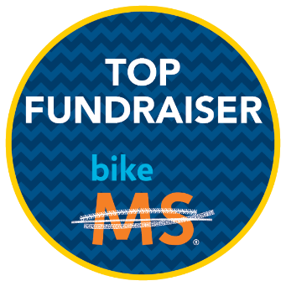
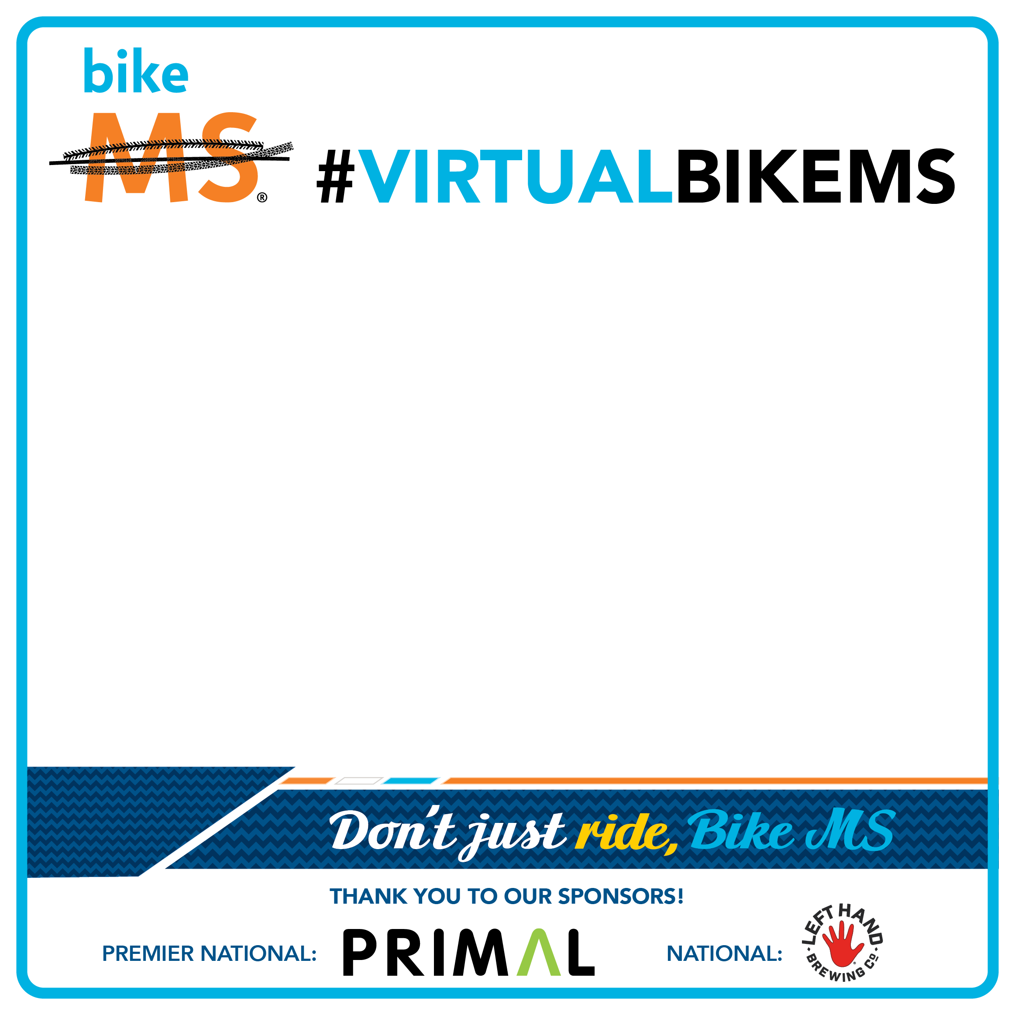
RIDER:
Insert Name
_______________________________________________________________

TEAM:
Insert Name
_______________________________________________________________

Click & drag the stickers to add to your bib!

Digital Bibs — “I Ride For” Template

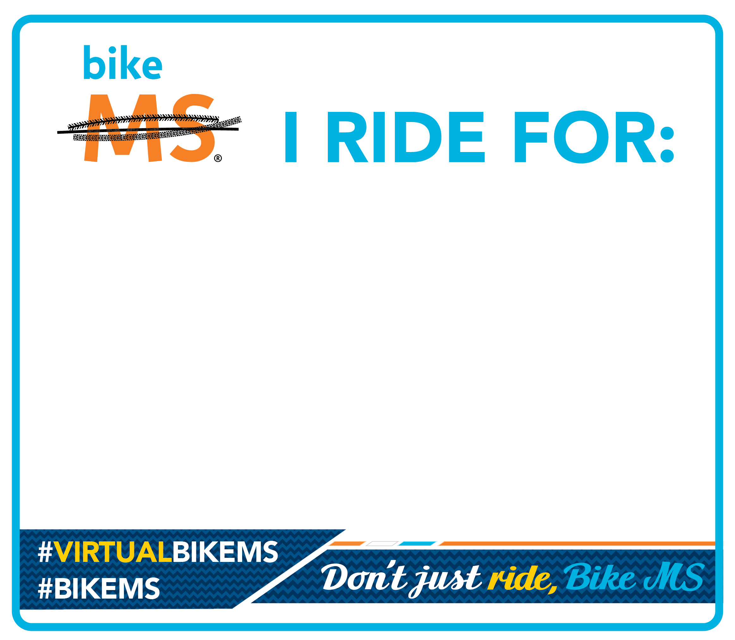
Insert Name
______________________________________

Digital Bibs — Top Fundraiser Club Template
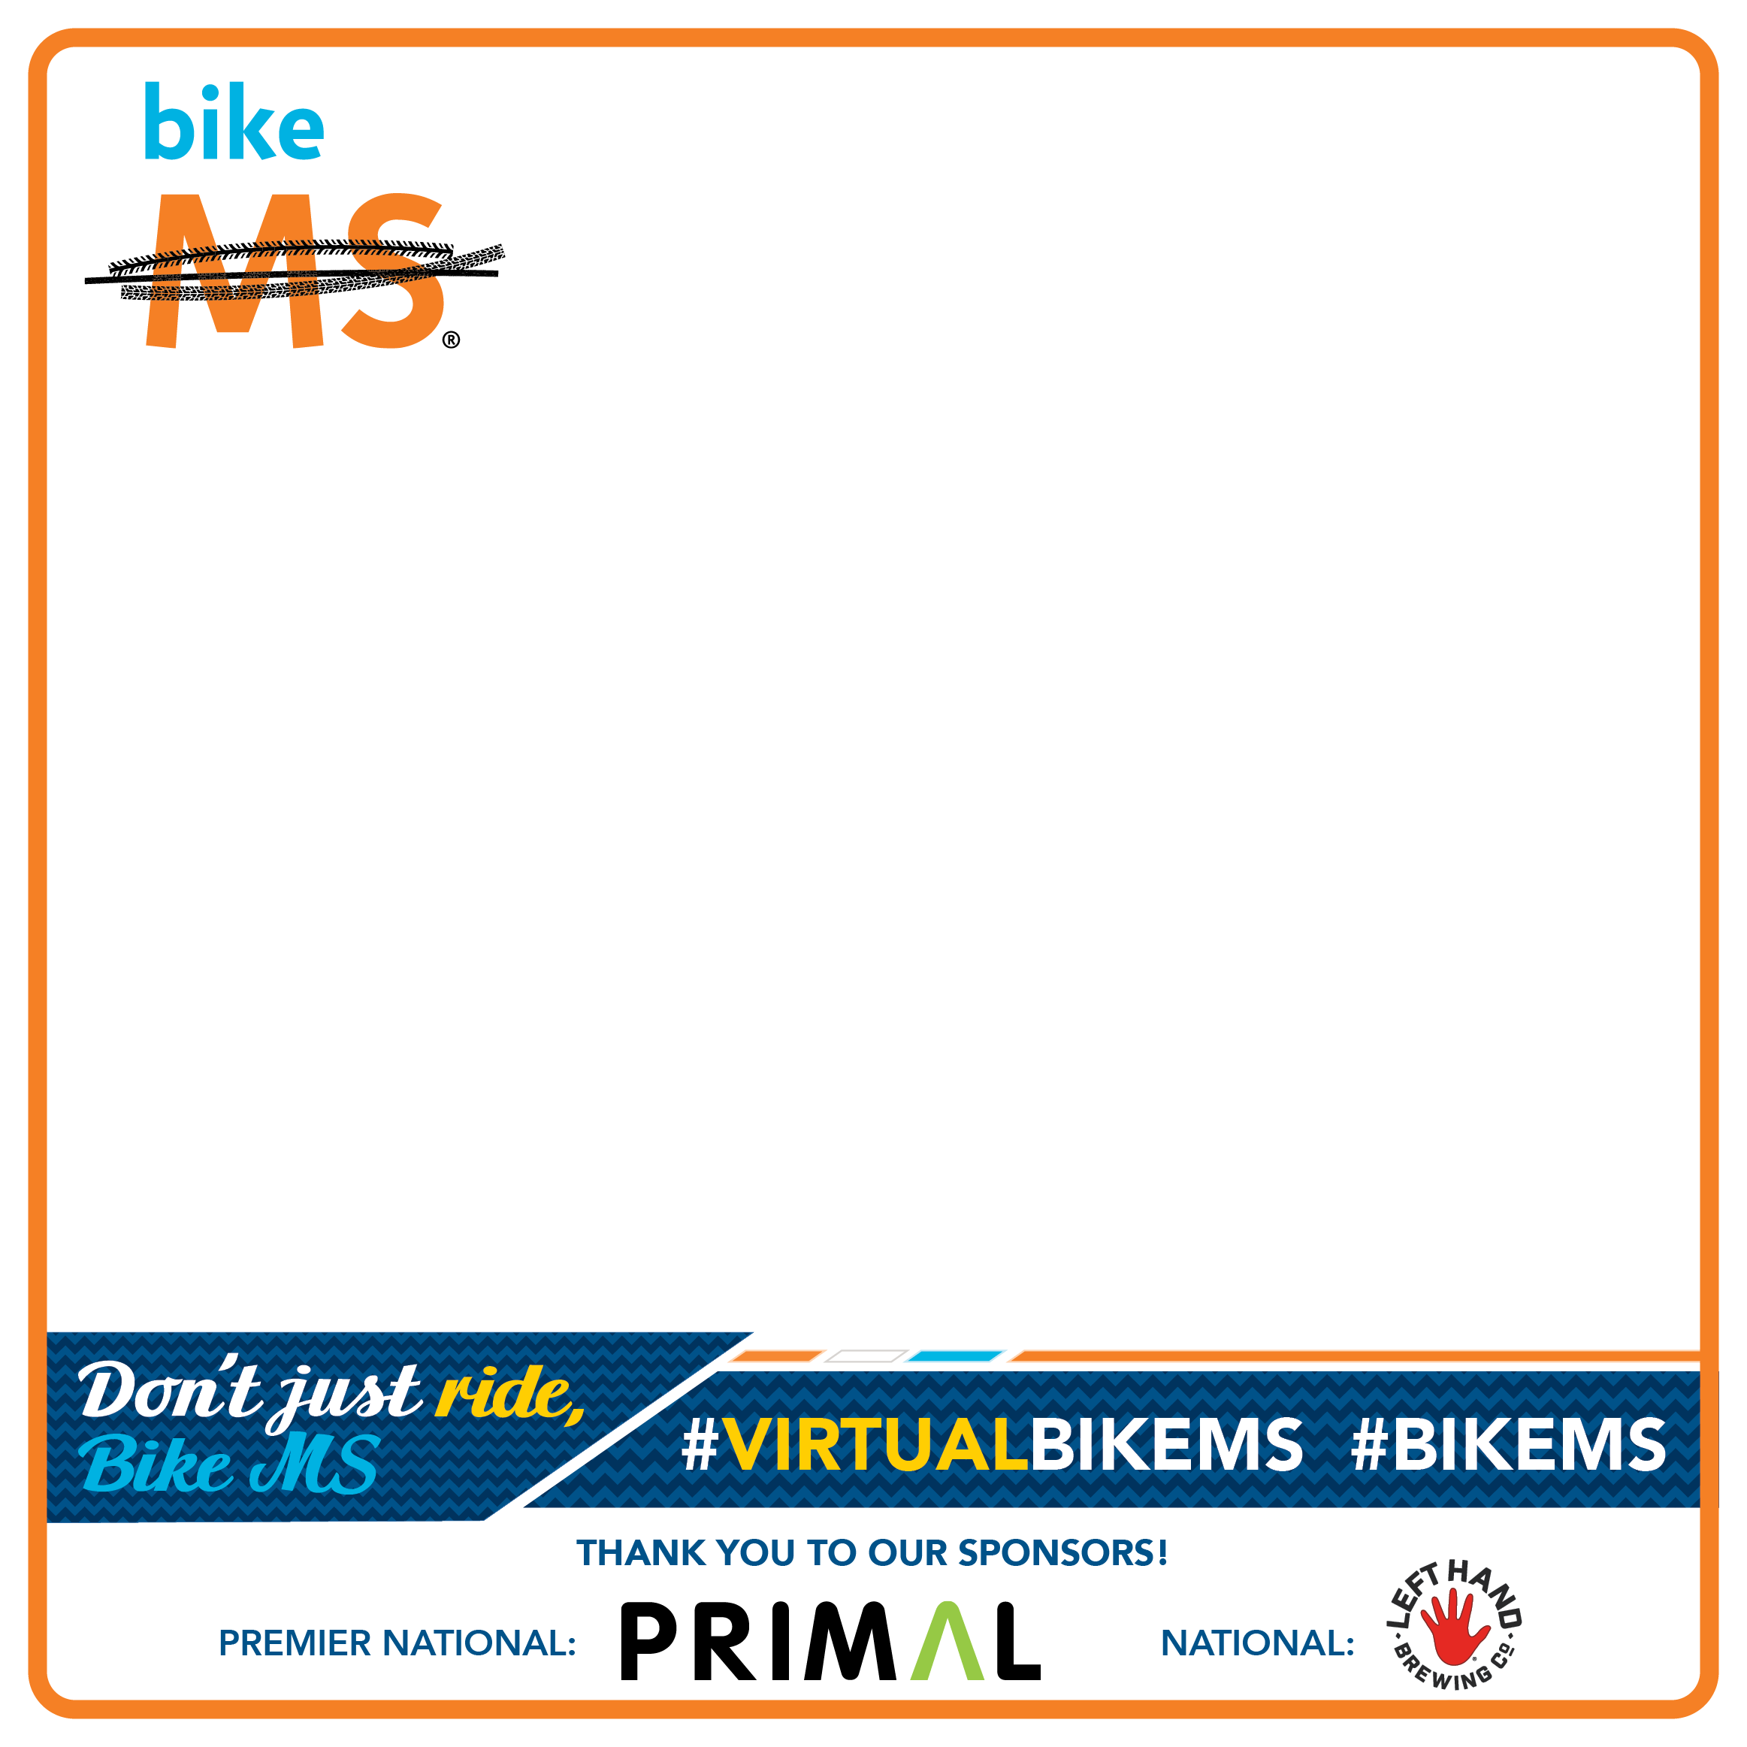
RIDER: First Name Last Name
TEAM: Team Name

RIDE NAME

< TOP FUNDRAISING CLUB NAME >
000

Click & drag the stickers to add to your bib!

